Flash Flood Modeling Project

By Bailey Matias, Grace Warne, Nathaniel Jamison, Sejin Park

**Introduction**

Storms are a common phenomenon in the U.S. Specifically, from June to November hurricanes become a normal occurrence along the east coast. Hurricane Matthew was the most powerful hurricane to make landfall in the continental United States. It reached North Carolina as either a Category 1 or 2 hurricane at around October 8, 2016, and resulted in 25 deaths in the state, in addition to costing about $10.3 billion in damages. Major flooding materialized in areas near Fayetteville, North Carolina, picking up over 8 inches of rain in 6 hours on October 8th and totaling over 14 inches. The National Weather Service office in Wilmington, North Carolina issued its first ever flash flood emergency due to the combination of rainfall and storm surge flooding. With this amount of destruction, it is important to identify high-risk flood areas in the various watersheds of the affected states. This project involves creating a flash flood model for a small study area that was affected by Hurricane Matthew. The study area was determined by the HU8 watershed shapefiles.

**Study Area**

The study area used for this project was an HU8 watershed area encompassing Greensboro and surrounding areas in North Carolina. The specific watershed being analyzed was the watershed of the Haw River, which was at least partially located in ten counties: Alamance, Caswell, Chatham, Durham, Forsyth, Guilford, Orange, Randolph, Rockingham, and Wake. However, Durham and Wake counties were removed from consideration in this project because of a large lake present in these counties which would have significantly affected the flow accumulation and flow direction models. In short, the study area was in the HU8 watershed Haw without two counties mentioned above. This area was chosen since there was enough precipitation caused by Hurricane Matthew to allow for a comparison between the rainfall from Hurricane Matthew and the rainfall from an expected one-year storm for the Haw watershed.

**Methods**

The data used for this project was NEXRAD data, which was obtained using a climate toolkit downloaded from the National Center for Environmental Information NEXRAD archive system. The NEXRAD station used was the one that was geographically closest to the study area. The type of data obtained was an L3[DSP] storm precipitation total at a radius of 230 kilometers from the station. Hurricane Matthew occurred in early October of 2016, so the time frame was determined by the period in which precipitation fell with no breaks lasting longer than two hours; for this study area, the period was from 18:00 GMT on October 6 to 14:00 GMT on October 9. This data had to be ordered; therefore a HAS number was sent via email, which was used in the climate toolkit, and the data exported. When processing this data, it is best to import the study area shapefile into the climate toolkit. The study area was centered and filled most of the screen since the view cannot be changed after animation has started. Next, the data was loaded and animated. The storm image that contained the highest precipitation totals was then exported for use in ArcGIS.

Before getting the soil data, counties were found which overlapped with the Haw River watershed in North Carolina. There were ten counties in the study area: Alamance, Caswell, Chatham, Durham, Forsyth, Guilford, Orange, Randolph, Rockingham, and Wake. However, on this project, the counties without Durham and Wake were omitted because these two counties contained big lakes, which would have significantly affected the flow accumulation and flow direction models. At the Web Soil Survey website, SSURGO 2.2 data was downloaded for each county. After downloading all data files was finished, each was unzipped and the access database opened. After the access database was opened, “stop all micros” was chosen for typing down the address of tabular data and the “OK” button chosen to close the file. For making soil shapefiles of each county, two data “soilmu_a..” shapefile were added from the spatial folder and the “component” table from soildb_US_2003 using ArcMap. Those two different files had to be one shapefile by joining the table into shapefiles with a field called MUCKEY and the data was exported into a new shapefile. All the above steps were repeated for the rest of the other seven counties. After exporting all counties’ shapefiles, ArcGIS was opened, the shapefiles added, and the Merge tool used to combine all counties into one polygon. Using the select by location tool, the study area was selected within the eight counties and exported into a new shapefile. The attribute table was opened for checking “hydgrp” field which indicated each field as A, B, C, or D. If the fields were <null> values in “hydgrp” field, they were edited based on the values of runoff. For each class, A was very low, B was medium, C was high, and D was very high. For calculating a curve number, it was necessary to create a new field called “hydgrp unit” which represented a numeric value of “hydgrp” field such as A=1, B=2, C=3, C/D or D = 4, and <null> = 5, this was done since tools in later steps would not be able to handle numeric units.

After the values in the soils layer were calculated, the soil had to be combined with a land cover raster in order to determine the runoff for the watershed under consideration. Prior to combining the layers, the land cover raster had to be obtained from the Geospatial Data Gateway, provided by the USDA and NRCS. The state of North Carolina was downloaded and the watershed was clipped out of the state layer to make the watershed its own layer. Areas with large lakes or other water bodies are also omitted as above since these areas were considered a liability for calculating accurate data. For removing these areas, the Extract by Mask tool was used. In this case, the soil layer from earlier was downloaded in order for both layers to be on the same project. Before the soil could be combined with the land cover layer, the soil also had to be converted to a raster, since the land cover was in raster form, but the soil in vector form. When the layers were combined, the equation *NLCD * 10 + Soil* was used.

The data for elevation was downloaded from the Geospatial Data Gateway. Six of the datasets were needed to cover the entire Haw watershed. The tool Mosaic to New Raster was used in order to merge these six separate raster layers together into one raster. A noticeable increase in elevation from the southeast to the northwest of our watershed.

After combining the soil and land cover raster layers, a “curve number” had to be provided to predict the runoff which would occur from various surfaces based on what average soil conditions would be under normal circumstances (i.e. not during a flood), as previously calculated by the USGS, in addition to the calculations which were already completed for the soils layer concerning runoff, since information for both layers now needed to be combined. Using Reclassify, each value which originally had a value of A to E and later converted to 1 to 5 was evaluated based on the USGS table provided predicting presumed runoff on various surfaces compared to each type of soil (1-5). For example, the land cover assigned as Developed, Open Space, was given the values 39, 61, 74, and 80, for the hydrologic soil groups 1-4, with 5 always being 100 for each land cover; 100 being high runoff and 0 being no runoff.

After determining the curve numbers for the combined land cover and soil layer, a soil retention layer was created using the raster calculator and the following function: , with CN representing the USGS curve numbers. This S layer was used to create to separate runoff layers, one for the one-year storm data and one for Hurricane Matthew. The equation used in the raster layer was , with a certain condition: if P < .2S, Q = 0.

The next step in this process involved creating the flow direction and flow accumulation. The flow direction method requires the DEM 30 m elevation data for the study area, and this output is used as the input for the flow accumulation method. For flow accumulation, three different rasters were created: one without any weight, one using the one-year storm runoff as weight, and one using the Hurricane Matthew runoff layer as weight. To remove effects from sheet flow, both of the weighted rasters were reclassified by setting any values less than 1000 equal to 0.

The final part of this lab had the storm’s percentage of the one-year flow accumulation calculated using the raster calculator. This was the equation used: . This was then reclassified based on its value to show the amount of probability, as shown in Table 1-1 below. The expand function was used to create symbols ranked by size.

|  |  |  |
| --- | --- | --- |
| Values | Reclass Value | Label |
| 2.1 - 3.0 | 1 | No probability |
| 3.0 - 3.5 | 2 | Extremely low probability |
| 3.5 - 4.0 | 3 | Very low probability |
| 4.0 - 7.0 | 4 | Moderately Low probability |
| 7.0 - 10.9 | 5 | Low probability |

Table 1-1: *The reclassified values and labels for five intervals of Image 1*

This layer was used to create the final map, Image 1, using the labels as shown above.

**Results and Discussion**

***Final Map (Image 1)***

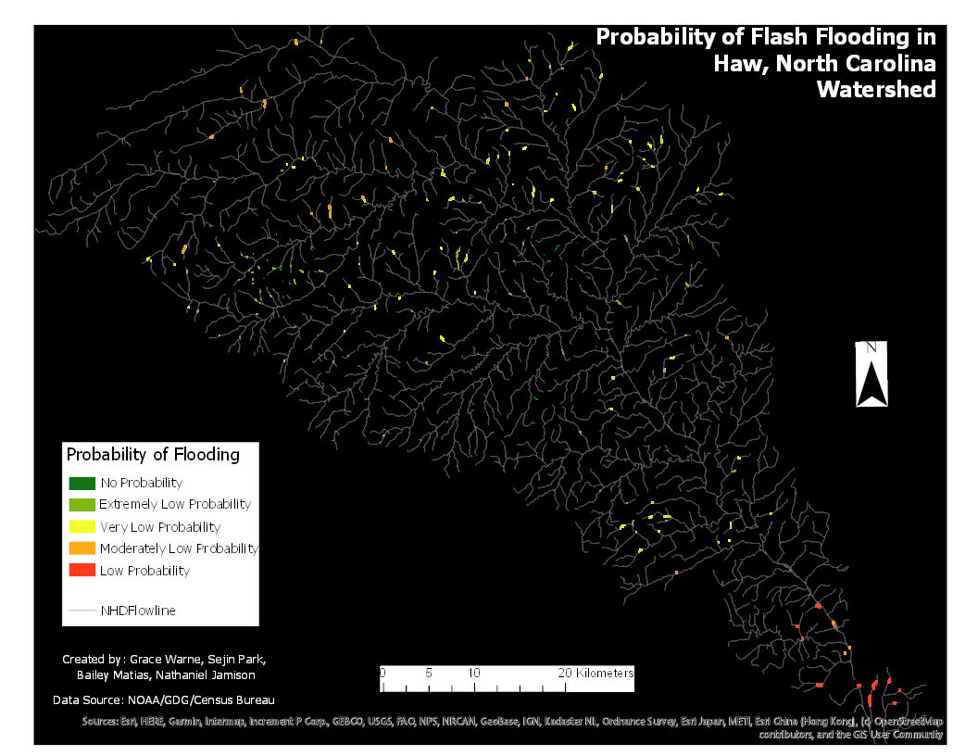

As one can see from table and the final map above, the result of calculating all the equations and putting the data into map layers resulted in nearly all locations in the study area being evaluated as having a starkly low probability of a flood, this in spite of the fact that rainfall received in most areas was fairly significant (rainfall ranged from 3.84 to 7.56 inches), given the time period in which rainfall occurred, even though the rainfall during this event was admittedly lower than other areas closer to the coast, where effects of the storm were more severe. There are many variables which could have contributed to these findings, chief among them, the fact that the this particular study area apparently has a certain level of aspect or slope near streams and rivers which ranges from around 50 to 300 meters. In other words, there are extensive areas where streams and rivers are elevated lower than the surrounding landscape, casing there to be a much smaller floodplain, and hence, less flooding occurs and overall flooding becomes more unlikely. This is the primary hypothesis and conclusion which was made as a result of the data found and documented in the charts and maps provided. This can also be proven when looking at the elevation map, where stream and river levels remained almost universally shaded in green regardless of surrounding landscape, which could have resulted in a riverbank possibly averaging 50 to 100 meters high.

Furthermore, areas closest to where lakes were located had a significantly higher risk of flooding, at least within the probabilities which were found. This could be not only because lakes obviously are made of water and because water usually feeds into them, as in this case, but also because the landscape of the the areas around lakes could presumably have less aspect in these areas. This again can be proven by observing the elevation map, where areas around lakes are much lower in elevation and elevation is much more homogeneous across the area.

It should be noted that the aspect and slope of the study area is not especially significant, compared to other possible places, as there are no mountains there and the area is located in what is generally considered the piedmont region. As stated above, elevation only ranged from around 50 to 300 meters. However, the aspect and/or slope which does exist there evidently is enough to ensure that most areas would not receive significant flooding during an event of this type, except in areas where lakes are located, most of which were omitted from the study area specifically to avoid higher numbers which would skew the results, and which certainly would have here, since findings were very low and because flooding on or near lakes is clearly more probable.

**Conclusion**

Compared to other watersheds affected by Hurricane Matthew, the Haw watershed had a low risk of flooding caused by the precipitation, and the worst areas in the Haw watershed still only had a low probability of flooding. This was the result of not only relatively low rainfall compared to other watersheds but also the study area’s small floodplain, which limited the areas that were at risk of flooding. While the Haw watershed experienced some rainfall during the hurricane, ultimately, this was not enough to create a significant flooding risk.

**References**

<https://hdsc.nws.noaa.gov/hdsc/pfds/pfds_map_cont.html?bkmrk=nc>

<https://www.ncdc.noaa.gov/nexradinv/>

<https://websoilsurvey.sc.egov.usda.gov/App/WebSoilSurvey.aspx>

<https://www.census.gov/cgi-bin/geo/shapefiles/index.php?year=2010&layergroup=Roads>

<https://datagateway.nrcs.usda.gov/GDGOrder.aspx>

<https://www.weather.gov/ilm/Matthew>

<https://weather.com/storms/hurricane/news/hurricane-matthew-bahamas-florida-georgia-carolinas-forecast>

**Appendix**

***Image 2: Introductory Map***

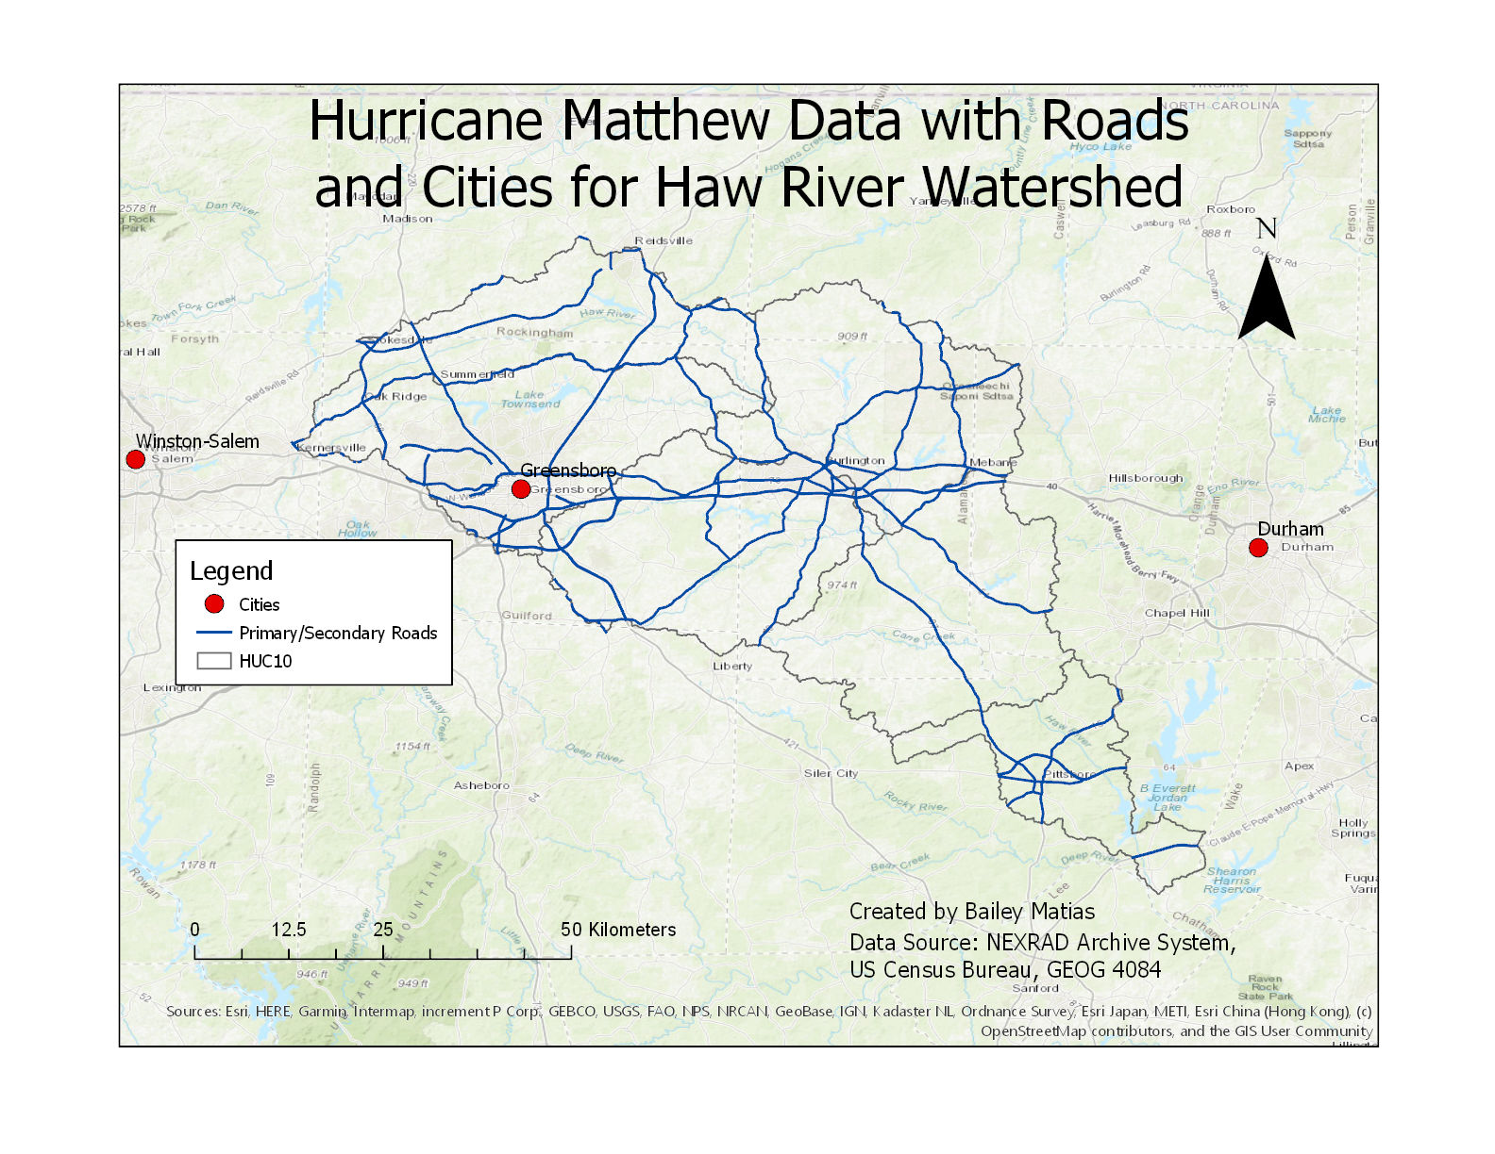

***Image 3: Precipitation Total Map***

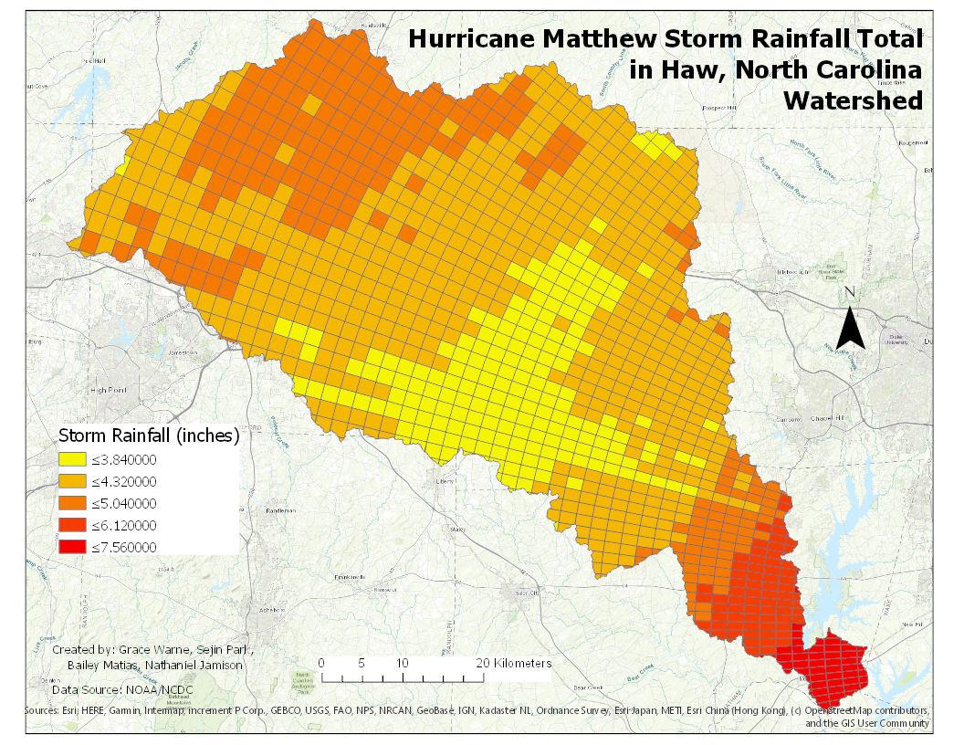

***Image 4: Elevation Map***

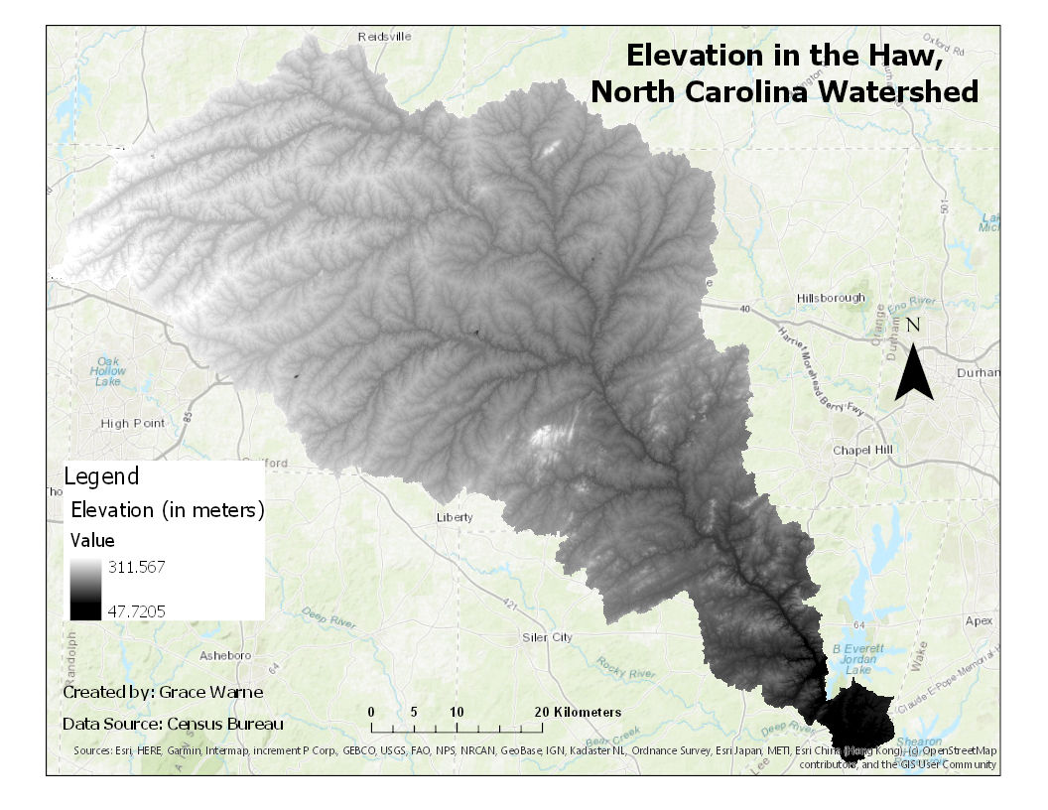

***Image 5: Streamline Map***

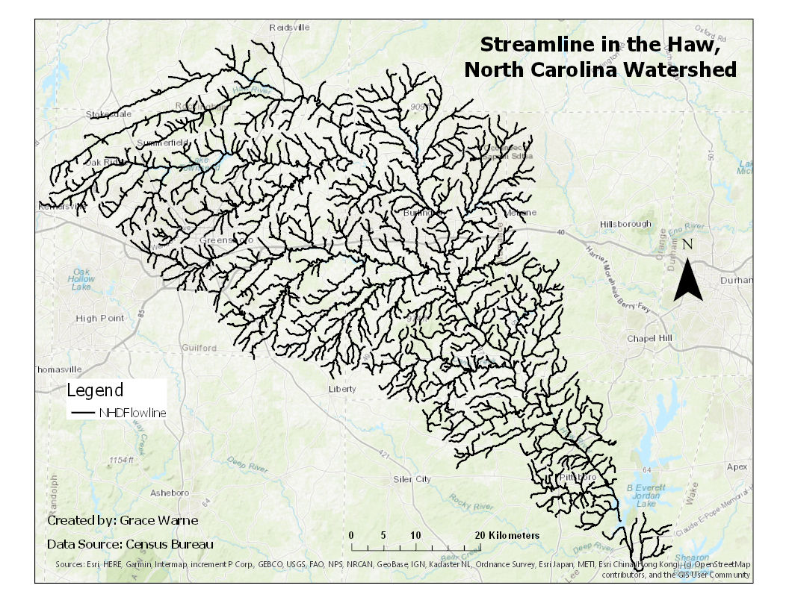

***Image 6: Flowchart***

